UNIT-I
Eigen values and Eigenvectors
Observation:
Definition of Eigen values: An eigenvalue of a square matrix A is scalar λ such that:

Ax= λx Where x is a non zero vector called the eigenvector
The number $λ$is the eigenvalue corresponding to eigenvector X.
Example 1: Simple 2×2 Matrix
Given matrix:
A = [ 2 1
1 2 ]
To find the eigenvalues, we use the formula: |A - λI| = 0
Step 1: Find A - λI
A - λI = [ 2-λ 1
1 2-λ ]
Step 2: Take determinant |A - λI| = 0
| 2-λ 1 |
| 1 2-λ | = 0
Using determinant formula: (2-λ)(2-λ) - (1)(1) = 0
(2-λ)² - 1 = 0
Step 3: Solve the equation : (2-λ)² = 1
2 - λ = ±1
Case 1: 2 - λ = 1
λ = 2 - 1
λ = 1
Therefore, λ₁ = 1
Case 2: 2 - λ = -1
λ = 2 + 1
λ = 3
Therefore, λ₂ = 3

The eigenvalues of the given matrix: λ₁ = 1 λ₂ = 3
Hence, the required eigenvalues are 1 and 3.

Application of Egin values and eigen vectors:

Eigenvalues help determine whether a system is stable, unstable, or oscillatory.
If eigenvalues are negative → system returns to equilibrium (stable).
If positive → system grows without bound (unstable).
If imaginary → system oscillates.
- Principal Component Analysis (PCA) in Data Science

uses eigenvectors to find principal components,

which: Reduce dimensionality, Remove noise, Detect patterns, Improve machine-learning performance.
- Eigenvalues indicate how much variance each principal component explains.
- Google ranks websites using eigenvectors.
- The ranking vector is the dominant eigenvector of a large matrix
representing internet links.
- The eigenvalue tells how significant each webpage is.
4.Engineers use eigenvalues in control systems to Determine system response ,Predict overshoot and settling time, Improve design of controllers

Record:

Experiment : finding Real and Complex Eigenvalues Aim:- To find the real and complex eigenvalues of a of a given square matrix python
Definition: An eigenvalue of a square matrix A is scalar λ such that: Ax= λx Where x is a non zero vector called the eigenvector
Theory:
Eigenvalues are obtained by solving the characteristic equation: |A- λI|=0

Depending on the nature of the matrix the eigenvalues may be real or complex Python provides numerical and symbolic tools to compute eigenvalues accurately.

Algorithm:
  - Read the order of the square matrix.
  - Input matrix elements.
  - Compute eigenvalues using a Python library.
  - Display the real and complex eigenvalues.
  - Stop.

FLOWCHART:-
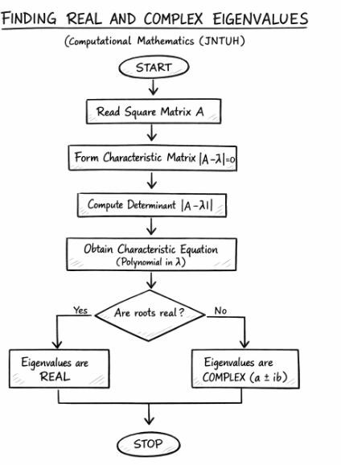

Program finding real and complex Eigen values.
- Real Eigen values:
import numpy as np

# Enter the matrix
A = np.array([[2, 1],
[1, 2]])

# Find eigenvalues
eigenvalues = np.linalg.eigvals(A)

print("Eigenvalues are:")

for value in eigenvalues:
if np.isreal(value):
print("Real eigenvalue =", value.real)
else:
print("Complex eigenvalue =", value)

Output:

Eigenvalues are:
Real eigenvalue = 3.0
Real eigenvalue = 1.0

- Complex Eigenvalues:
import numpy as np

# Enter the matrix
A = np.array([[0, -1],
[1, 0]])

# Find eigenvalues
eigenvalues = np.linalg.eigvals(A)

print("Eigenvalues are:")

for value in eigenvalues:
if np.isreal(value):
print("Real eigenvalue =", value.real)
else:
print("Complex eigenvalue =", value)
Output:
Eigenvalues are:
Complex eigenvalue = 1j
Complex eigenvalue = -1j

Observation:
# Find eigenvalues and eigenvectors

Definition:

Let A be a square matrix. A non-zero vector x is called an eigenvector of A if it satisfies: Ax=λx

Where λ is the corresponding eigenvalue.

Theory:
For a given matrix A, eigenvalues are first obtained by solving the characteristic Equation:
|A-λI|=0

For each eigenvalue λ, the eigenvector is obtained by solving:

(A-λI)x=0

Eigenvectors may be real or complex depending on the matrix.

Python provides efficient numerical methods to compute eigenvalues and eigenvectors.

Example: Let $A=\left(\begin{matrix}4 & 2 \\ 1 & 3\end{matrix}\right)$
Step 1: Find eigenvalues
Solve the characteristic equation:
$$det⁡(A-λI)=0$$
$$det⁡\left(\begin{matrix}4-λ & 2 \\ 1 & 3-λ\end{matrix}\right)=(4-λ)(3-λ)-2$$
Expand:
$$=λ^{2}-7λ+10=0$$
Factor:
$$(λ-5)(λ-2)=0$$
So eigenvalues are:
$$λ_{1}=5,λ_{2}=2$$
Step 2: Find eigenvectors
For $λ=5$:
Solve:
$$(A-5I)X=0$$
$$\left(\begin{matrix}-1 & 2 \\ 1 & -2\end{matrix}\right)\left(\begin{aligned}x \\ y\end{aligned}\right)=0$$
This gives:
$$-x+2y=0⇒x=2y$$
Eigenvector:
$$X_{1}=\left(\begin{aligned}2 \\ 1\end{aligned}\right)$$
For $λ=2$:
Solve:
$$(A-2I)X=0$$
$$\left(\begin{matrix}2 & 2 \\ 1 & 1\end{matrix}\right)\left(\begin{aligned}x \\ y\end{aligned}\right)=0$$
This gives:
$$2x+2y=0⇒x=-y$$
Eigenvector: ${ X}_{2}=\left(\begin{aligned}1 \\ -1\end{aligned}\right)$
RECORD
2. Experiment: Finding Eigenvectors of a Matrix

Aim:
To find the eigenvectors of a given square matrix using Python.

Algorithm
  - Read the order of the matrix.
  - Read matrix elements.
  - Compute eigenvalues of the matrix.
  - Compute eigenvectors corresponding to each eigenvalue.
  - Display eigenvalues and eigenvectors.
  - Stop.

FLOW CHART :-
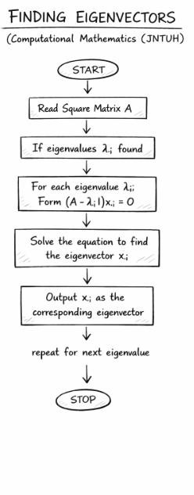

Program finding Eigen vectors.

import numpy as np

# Define the matrix
A = np.array([[4, 1],
[2, 3]])

# Find eigenvalues and eigenvectors
eigenvalues, eigenvectors = np.linalg.eig(A)

print("Matrix A:")
print(A)

print("\nEigenvalues:")
print(eigenvalues)

print("\nEigenvectors:")
print(eigenvectors)

# Display each eigenvalue with its corresponding eigenvector
for i in range(len(eigenvalues)):
print("\nEigenvalue =", eigenvalues[i])
print("Corresponding Eigenvector =", eigenvectors[:, i])

output:

Matrix A:
[[4 1]
[2 3]]

Eigenvalues:
[5. 2.]

Eigenvectors:

[[-0.70710678 -0.4472136 ]
[-0.70710678 0.89442719]]

Eigenvalue = 5.0
Corresponding Eigenvector = [-0.70710678 -0.70710678]

Eigenvalue = 2.0
Corresponding Eigenvector = [-0.4472136 0.89442719]

